Hands-On Lab
Lab Manual
Using CppUnit in Microsoft Visual VC++

Contents
Using CppUnit in Microsoft Visual VC++ i
Lab 01: CppUnit in Microsoft Visual VC++ 3
Lab Objective 3
1 – Introduction to CppUnit 3
2 – Installing CppUnit 3
3 – Using CppUnit 3
3.1 CppUnit for Console application 3
3.2 CppUnit for Win32 application 16
3.3 CppUnit for MFC application 16
4 – Organizing the project code 28
5 – References 28

Lab 01: CppUnit in Microsoft Visual VC++
Estimated time to complete this lab: 60 minutes

Lab Objective
The objective of this lab is to introduce you how to using CppUnit in Microsoft Visual VC++.
- Introduction to CppUnit.
- Writing tests in CppUnit.
Prerequisite:
- Microsoft Visual VC++

1 – Introduction to CppUnit
CppUnit is a unit testing framework module for the C++ programming language, described as a C++ port of JUnit. The library is released under the GNU Lesser General Public License. It allows unit-testing of C sources as well as C++ with minimal source modification.
The framework runs tests in suites. Test result output is sent to a filter, the most basic being a simple pass or fail count printed out, or more advanced filters allowing XML output compatible with continuous integration reporting systems.
The project has been forked several times. The freedesktop.org version, maintained by Markus Mohrhard of the LibreOffice project (which uses CppUnit heavily), is actively maintained, and is used in Linux distributions such as Debian, Ubuntu, Gentoo and Arch.

2 – Installing CppUnit
Installation of CppUnit can be broken down into the following steps:
- Get source code of CppUnit at here (http://sourceforge.net/projects/cppunit/files/cppunit/)
- Go to CppUnit folder. Click on Build2010.sln to open solution.
- Next step, build solution.
- And then go to lib folder. We will see: testrunnerd.dll, cppunitd.lib, cppunitd_dll.lib and testrunnerd.lib.

3 – Using CppUnit

3.1 CppUnit for Console application
- Create an empty application project

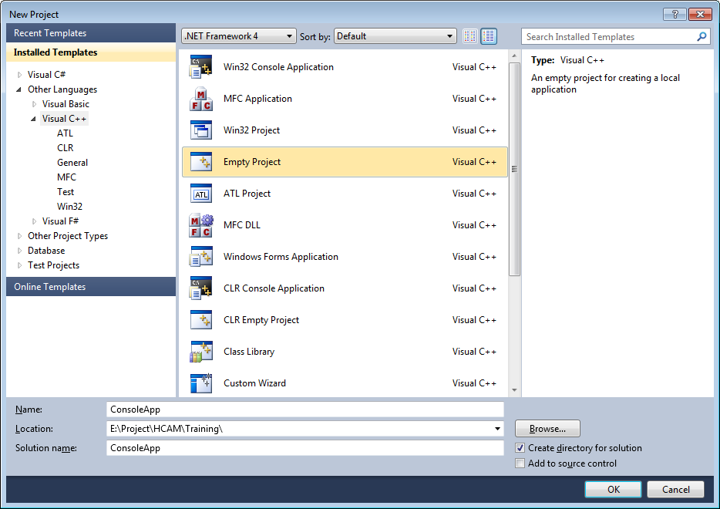

- Add a testing project into solution

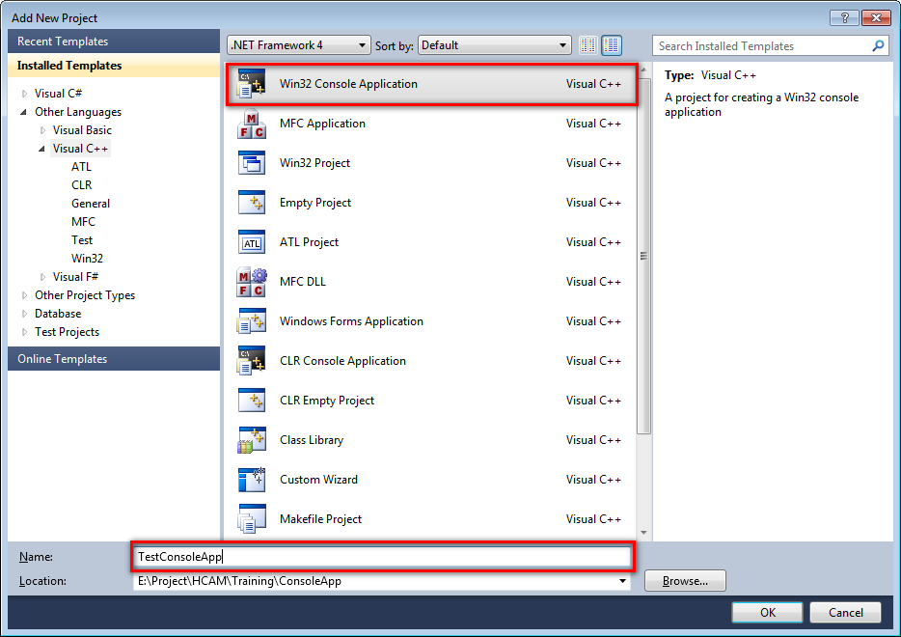

- Currently our source code have two projects

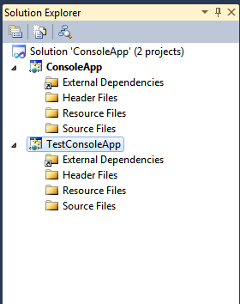

- Add class into application project. It’s called CComFunc
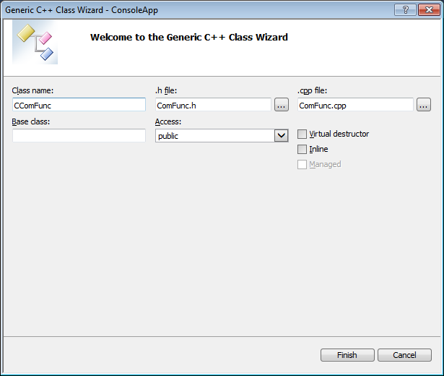

- Add method “Add” into CComFunc class

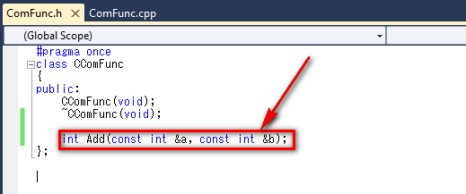

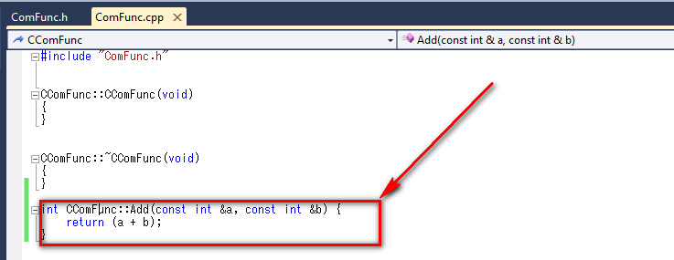

- Change configuration type for application project is static library (.lib)

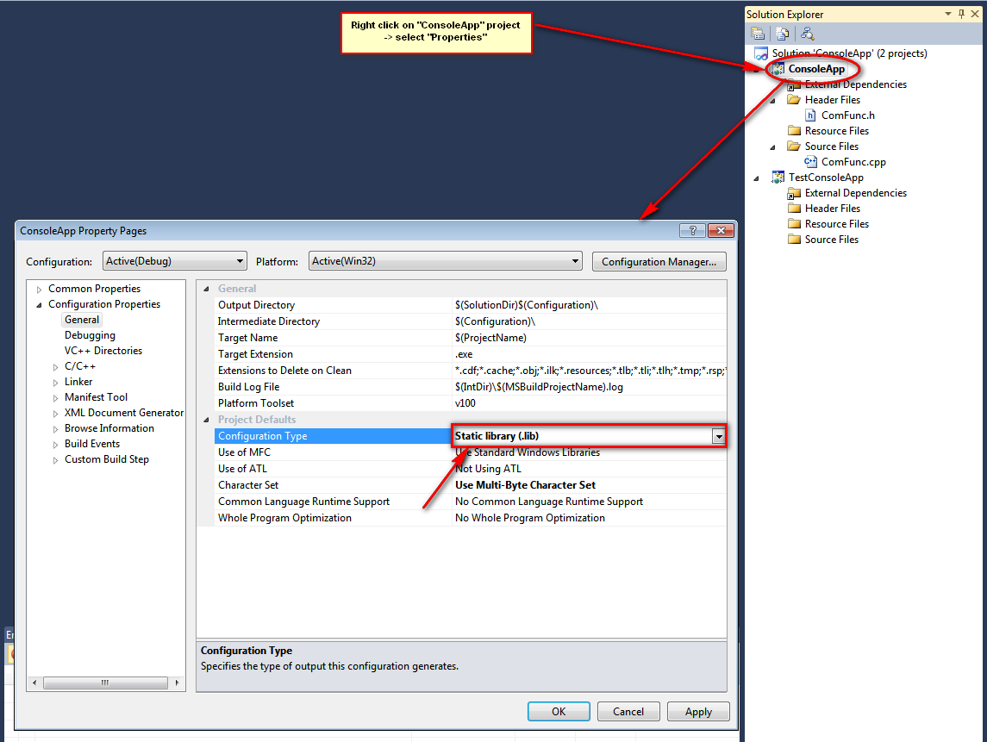

- Add class into test project. It’s called CComFuncTest
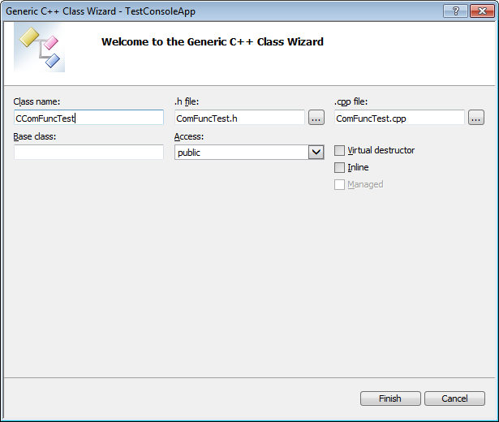

- Add reference test project to application project

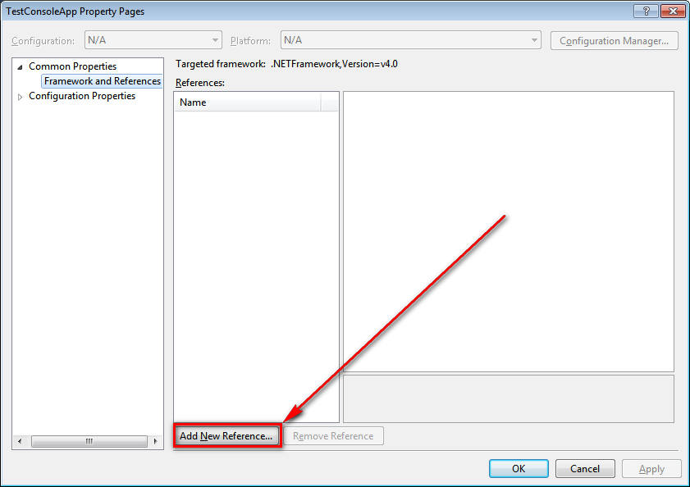

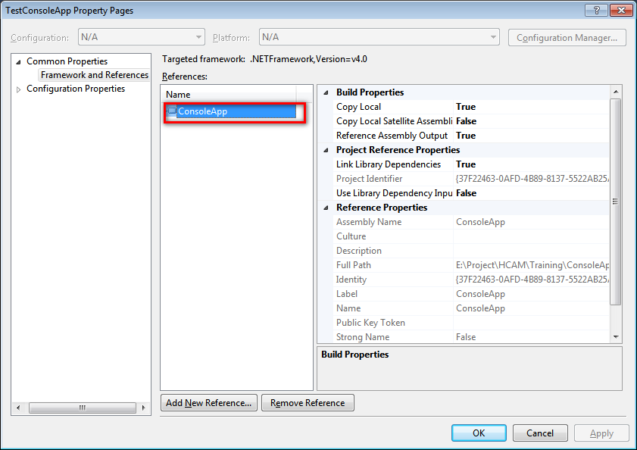

- Configuration test project
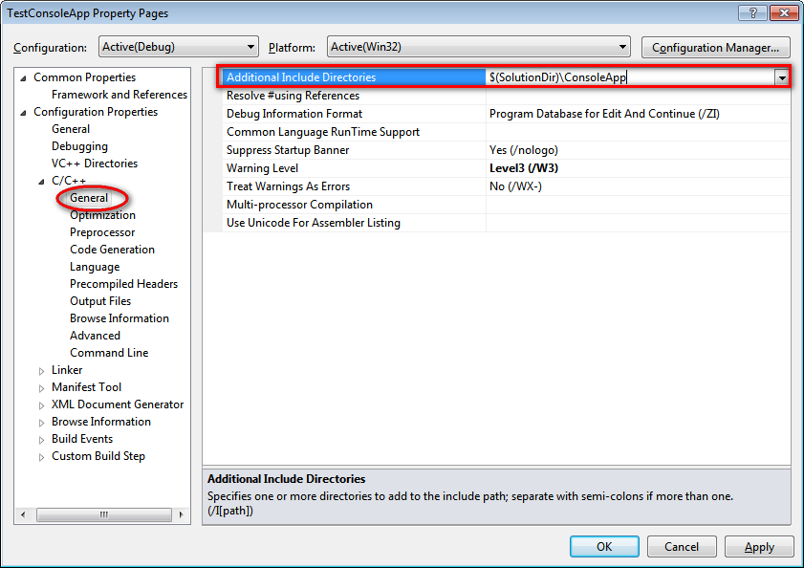

- Test invoke api from application project successfully.

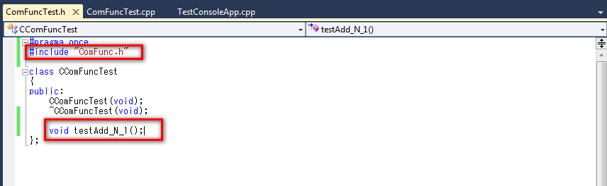

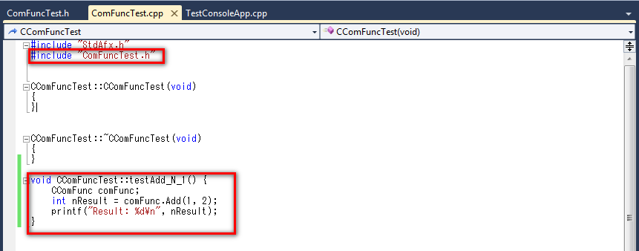

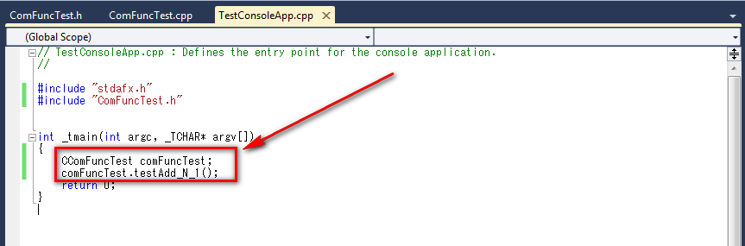

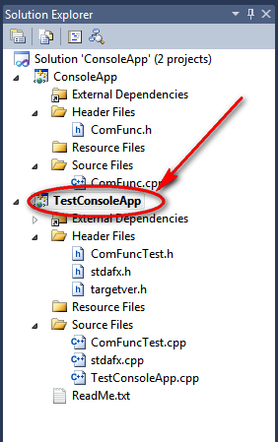
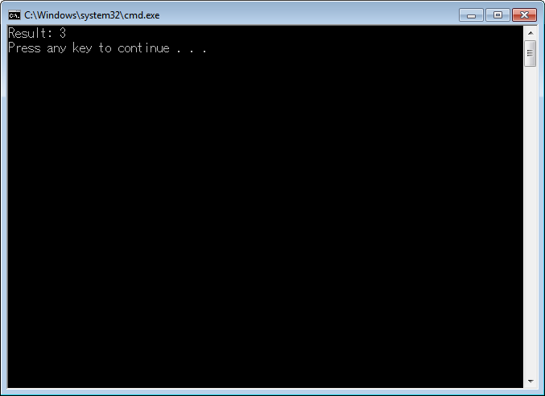

- Add configuration to use CppUnit library.

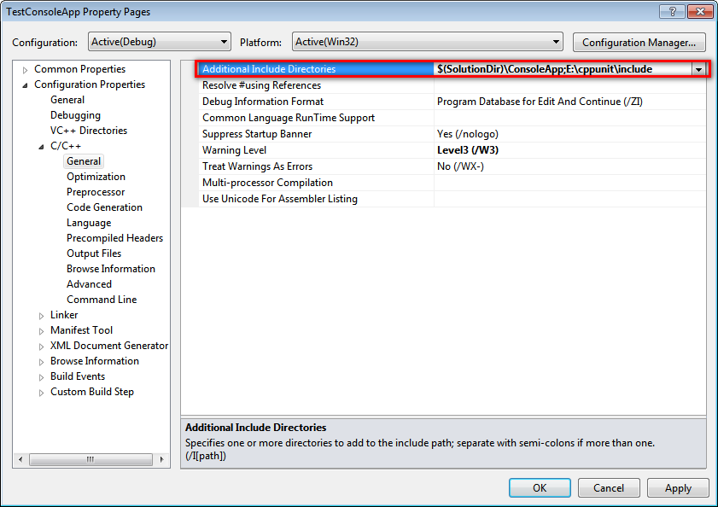
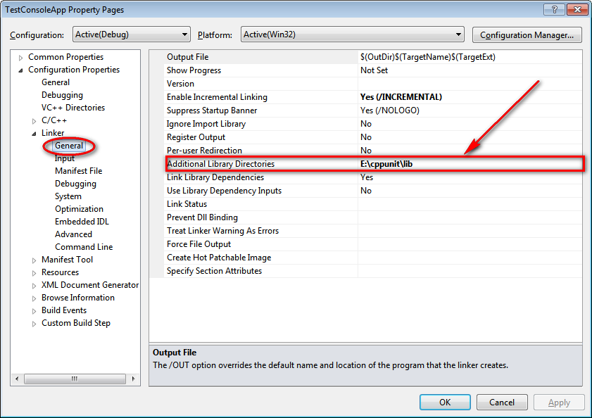

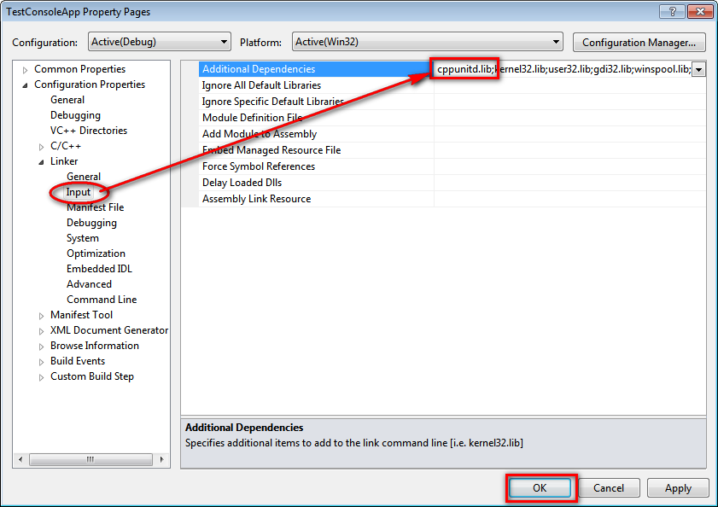

- Update code to run test case

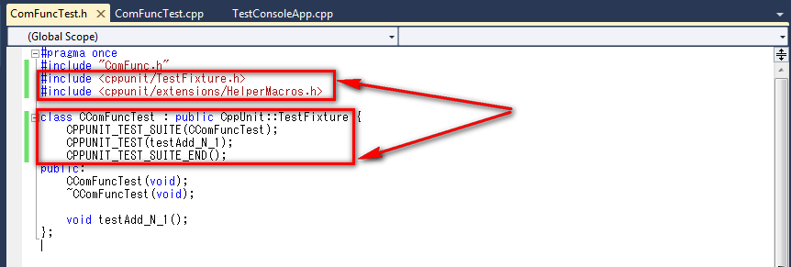

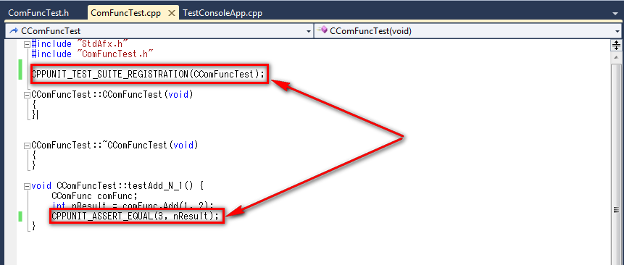

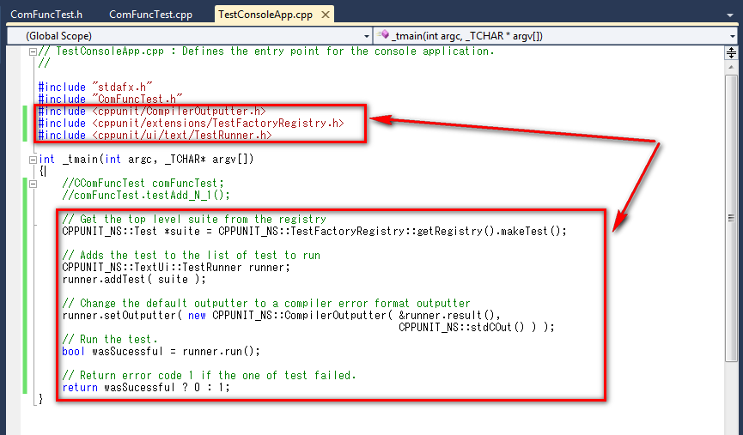

- Finally, press Ctrl + F5 to run project. We will see output

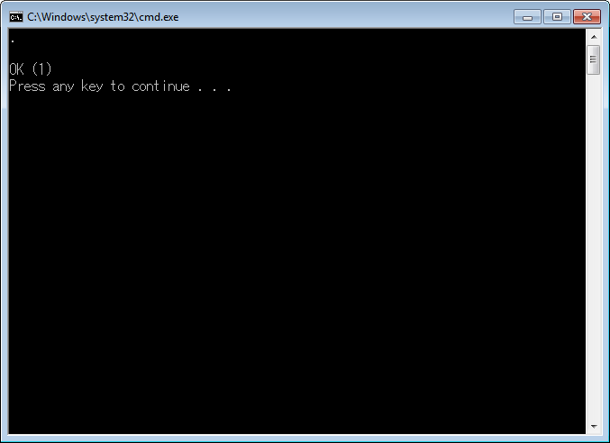

3.2 CppUnit for Win32 application

3.3 CppUnit for MFC application
- Create an MFC DLL project

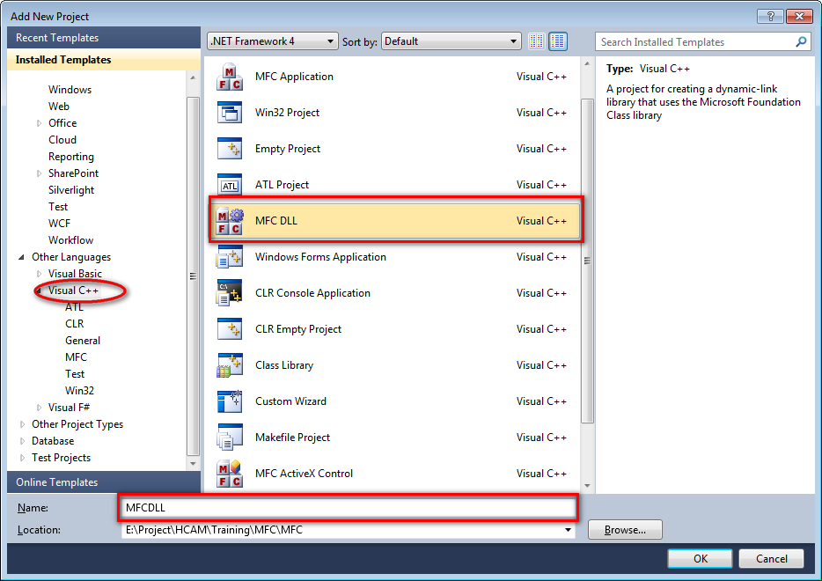

- Add a testing project into solution

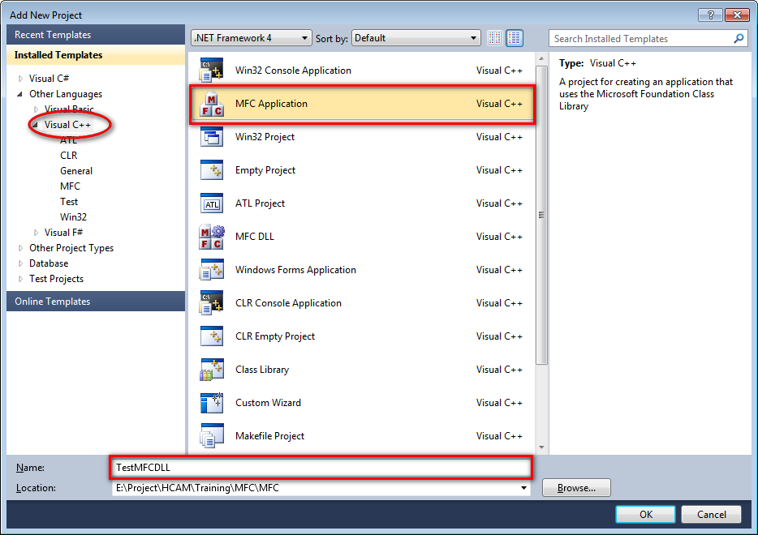

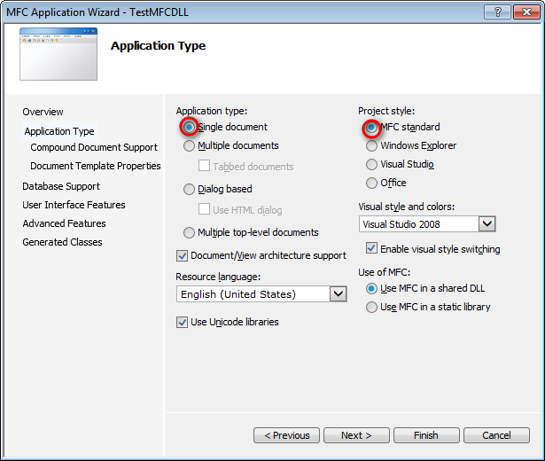

- Currently our source code have two projects

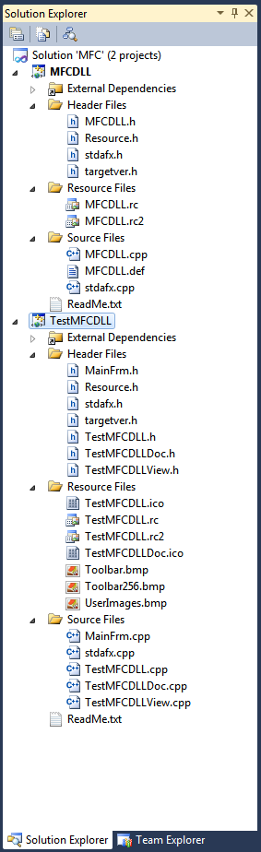

- Add class into application project. Its called MyClass

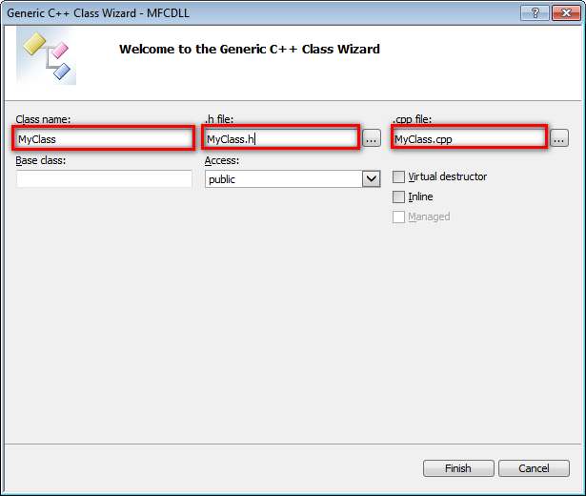

- Add method “Add” into CComFunc class

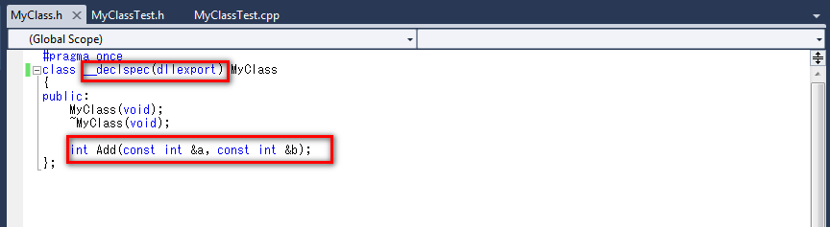

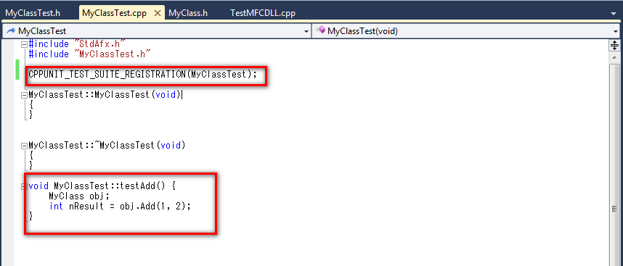

- Add reference test project to MFC DLL project

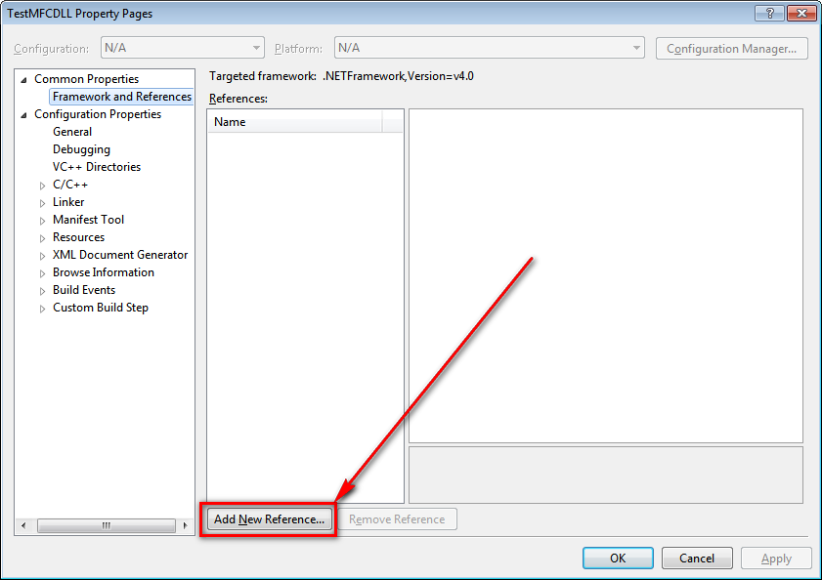

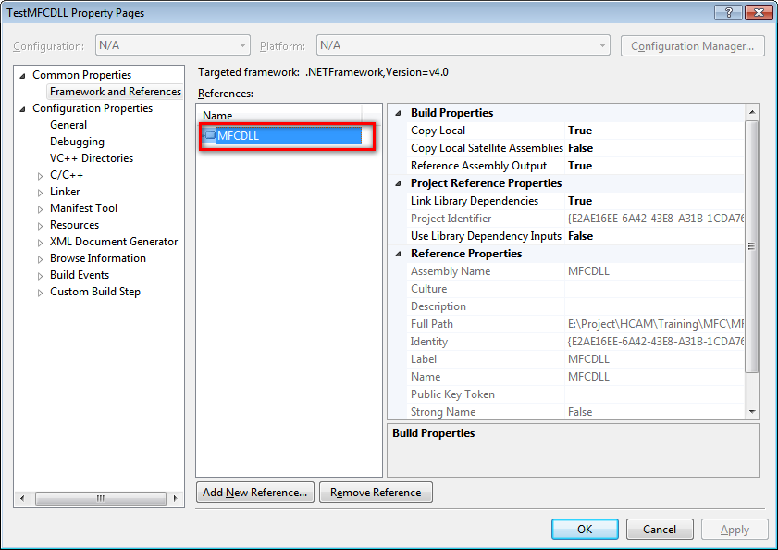

- Configuration test project

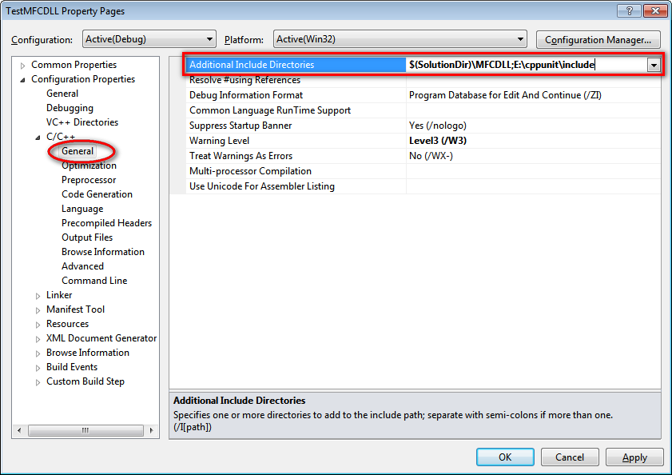
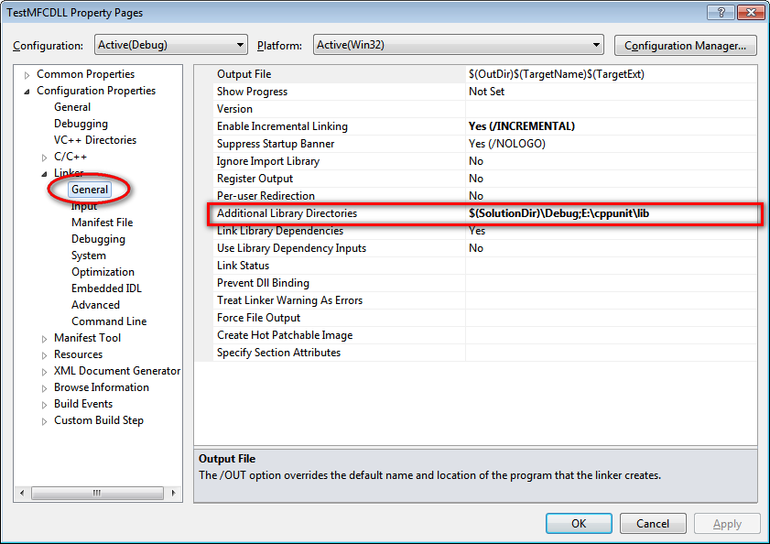

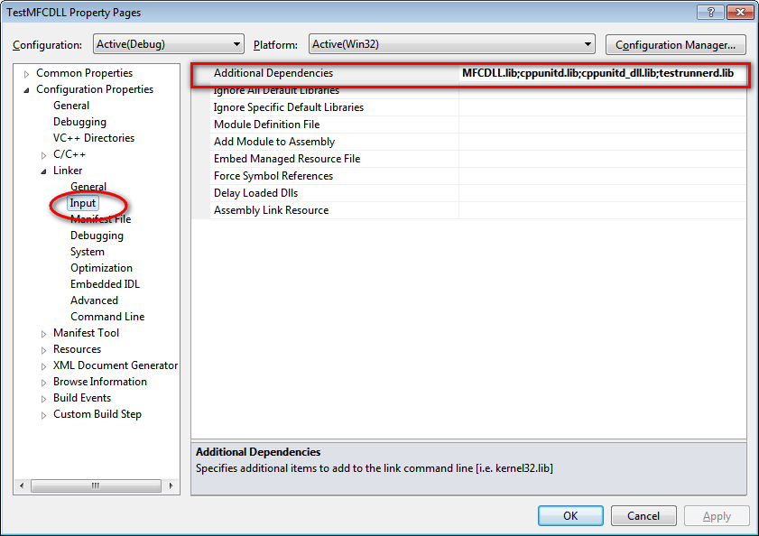

- Add class into test project. It’s called “MyClassTest”

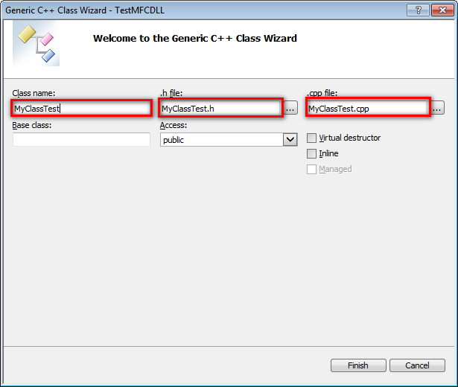

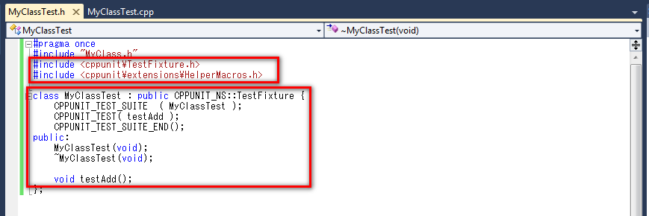

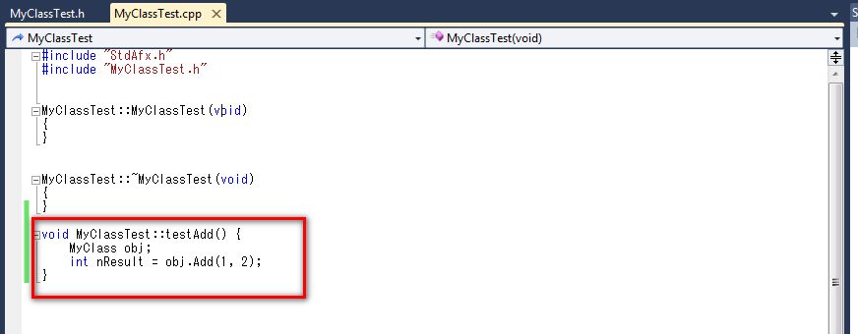

- Update code for “TestMFCDLL.cpp”

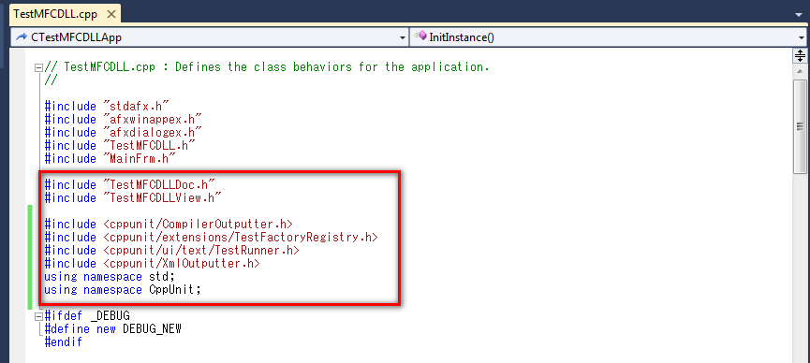

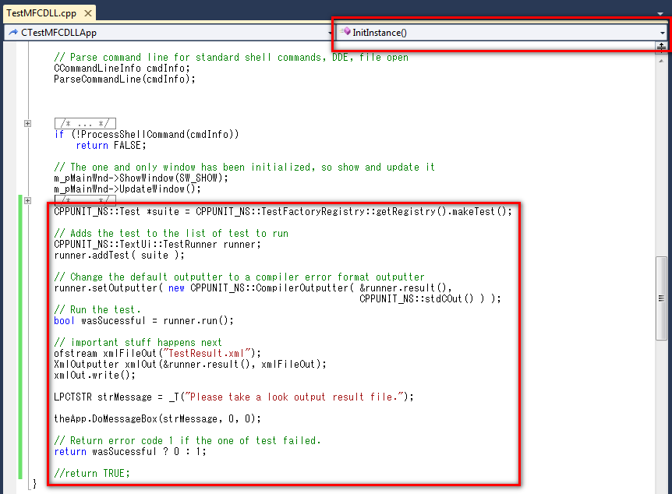

- Finally, press Ctrl + F5 to run project. We will see output

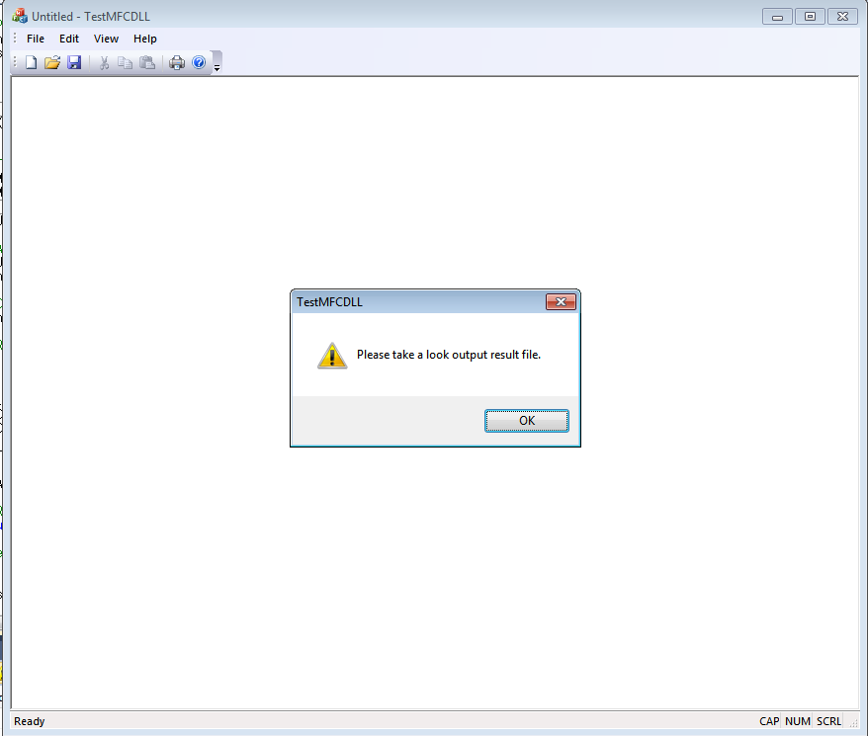

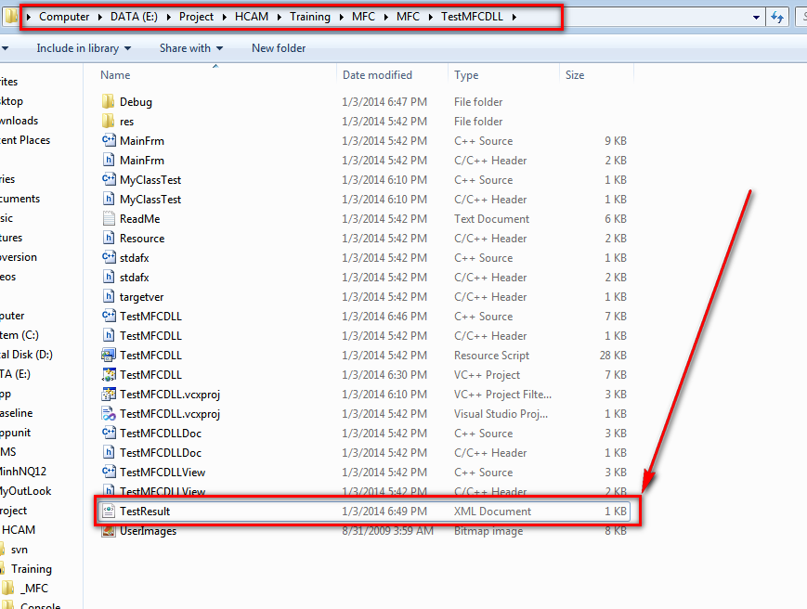

4 – Organizing the project code

5 – References

